Huber’s theory of adic spaces is one of many possible models for rigid analytic geometry, and the model that Scholze often chooses to adopt. This model seeks to mimic general scheme theory, and has many of the same advantages and disadvantages of that theory. Here are some other models.

* Tate’s theory of rigid analytic varieties – mimics classical theory of varieties over algebraically closed fields
* Berkovich’s theory of Berkovich analytic spaces – intermediate between Tate’s and Huber’s theories
* Raynaud’s theory of birational geometry of formal schemes – makes precise the notion that rigid analytic varieties over \Q_p are “generic fibers” of formal schemes over \Z_p
* Fujiwara-Kato theory – Generalizes Raynaud’s theory by constructing analogue of so-called “Zariski-Riemann space” of a formal scheme

Sources:

* Bhatt, Morrow, and Scholze, *Integral p-adic Hodge Theory*
* Scholze, *p-adic Hodge Theory for Rigid Analytic Varieties*
* Scholze, *Perfectoid Spaces*
* Youcis, “A Taster of Rigid Geometry (Pt I: The Tate Perspective)” [blog post]

Here’s the initial setup.

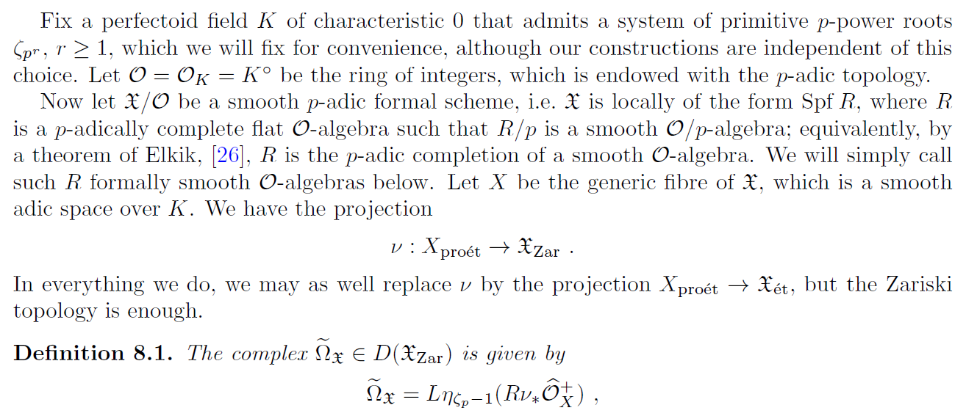

Note that the ideal (\zeta_p-1) is independent of the choice of \zeta_p. Our ultimate goal is to study the cohomology groups of this complex and identify them with differential forms on \mathfrak{X}. In order to understand what this complex looks like, we first need to understand all of the ingredients. At this point we’ve already spent some time studying decalage. The advantage of this tool is that it will allow us to convert almost results into genuine results (almost in the sense of almost mathematics). Here are the things we still need to understand.

* Formal schemes
* Adic spaces
* The pro-etale site associated to X
* The projection \nu
* The sheaf \w{\O}_X^+

For now, we will put off discussion of formal schemes. Suffice it to say that they capture important infinitesimal data often not present with ordinary schemes.

**Adic Spaces**

Let’s now think about adic spaces. One of the motivations is that we would like to cut out open subsets in a nonarchimedean setting using inequalities and analytic functions, much as we would in an archimedean setting. Letting B_{\C_p} be the closed unit disc (don’t worry about a precise definition), B_{\C_p} should be connected and quasicompact, and the global sections of its structure sheaf should consist of something like convergent power series. Doing things naively turns out not to meet these conditions.



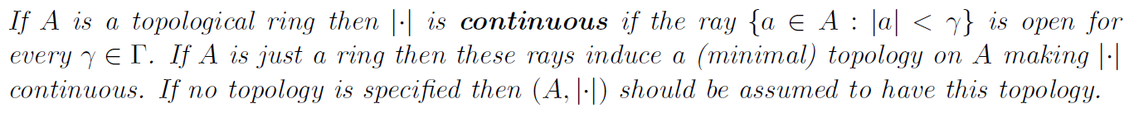

These valuations give rise to a generalized notion of point, calling back to the work of Weil and his predecessors in algebraic geometry. Given a field k, the following captures the notion of an affinoid k-algebra.

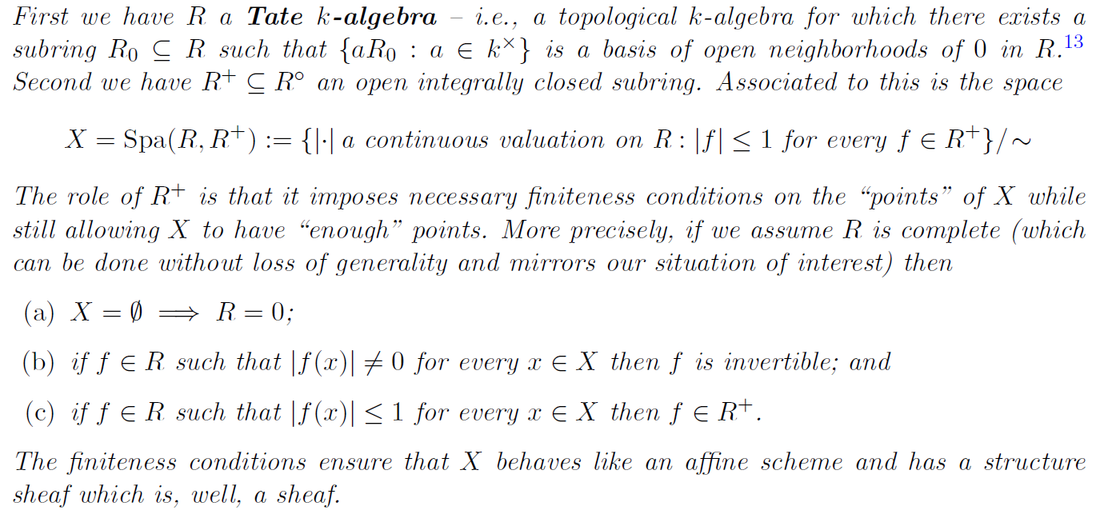

Let’s elaborate on the last point.

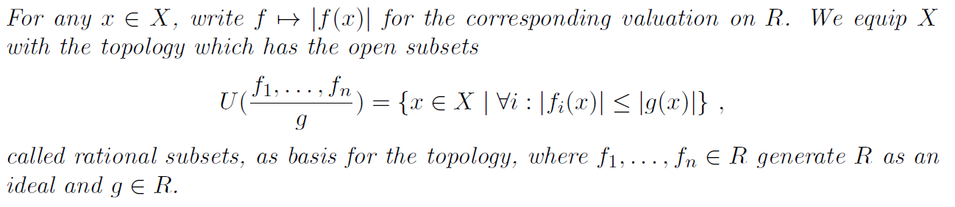

As mentioned a while ago, the space X=\Spa(R,R^+) equipped with this topology is spectral (i.e., homeomorphic to the \Spec of a ring equipped with the Zariski topology). Perhaps more relevant for us, though, is the fact that the rational subsets form a base of qc open subsets stable under finite intersections. Moreover, every irreducible closed subset has a unique generic point. The space X itself is qcqs (recall qs = quasiseparated = intersection of any two qc opens is qc). How do we define its structure sheaf?

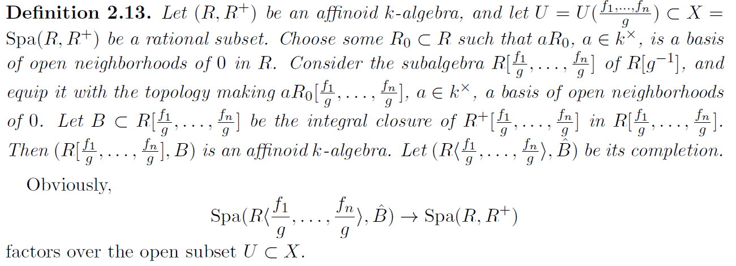

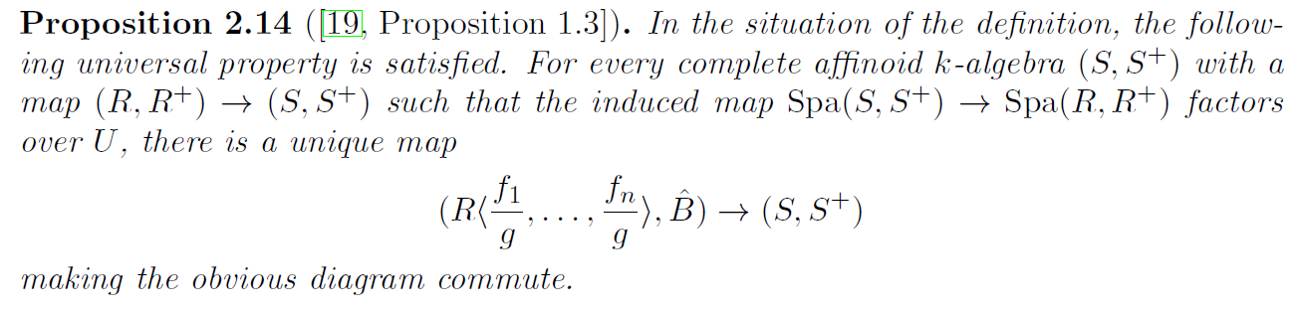

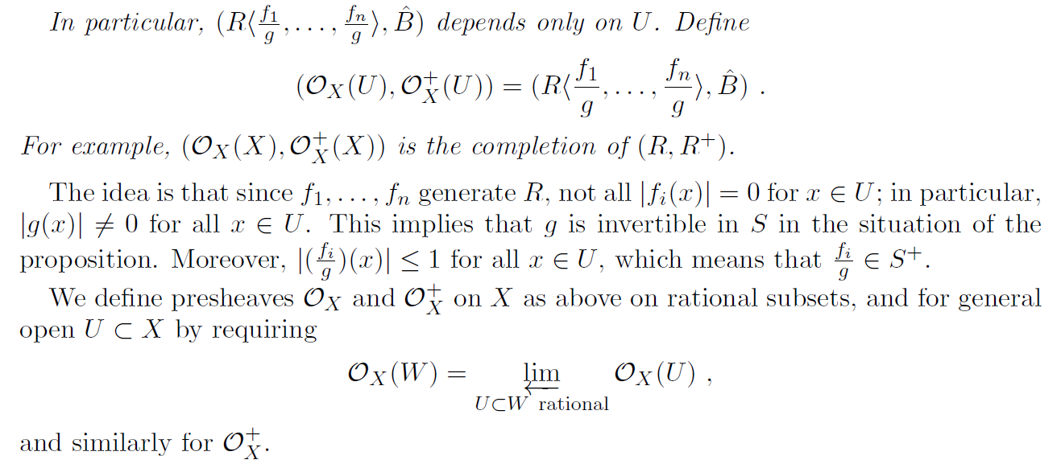

This gives \O_X and \O_X^+ as presheaves. Unfortunately, \O_X is probably not a sheaf in general (maybe this is known; I’m not sure). What is true is that \O_X^+ is a sheaf if \O_X is a sheaf. The following gives some of the geometric perspective we initially wanted.

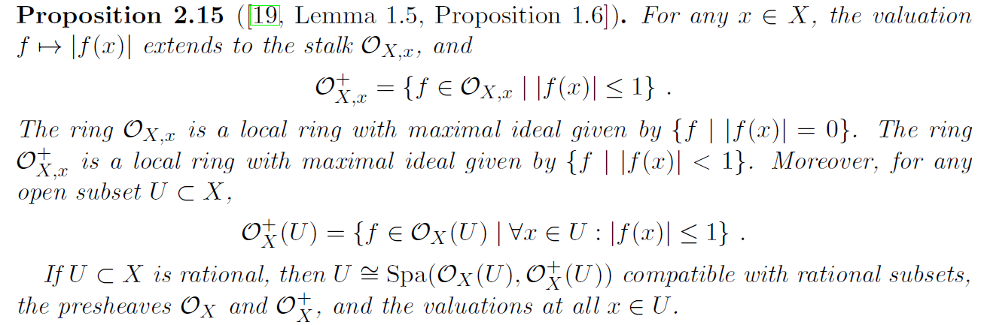

What conditions do we need to ensure that \O_X is a sheaf? One is to assume X is strongly Noetherian.

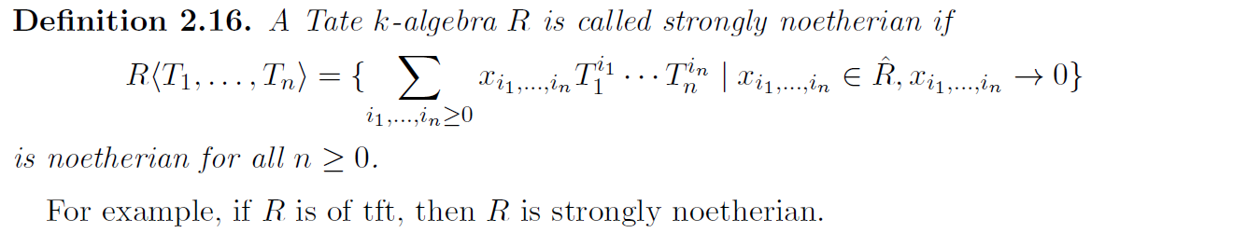

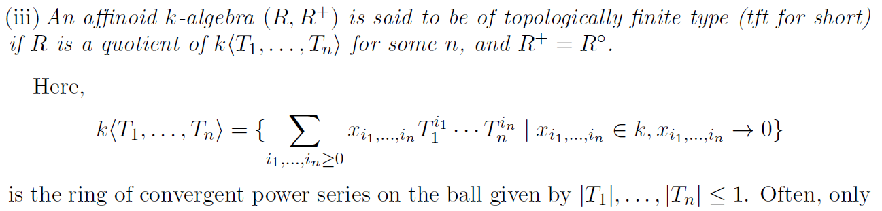

For us, what matters most if the following key theorem (for K a perfectoid field with \m=K^{\circ\circ}).

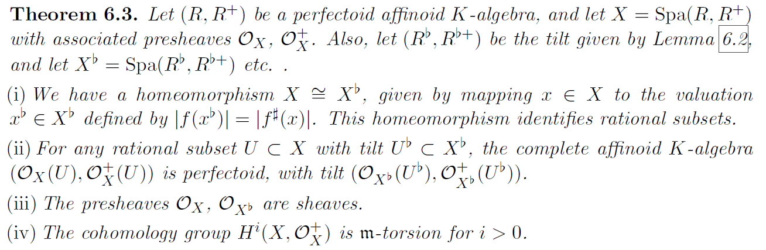

Just as for schemes, now that we have our analogue of affine schemes we can define general adic spaces.

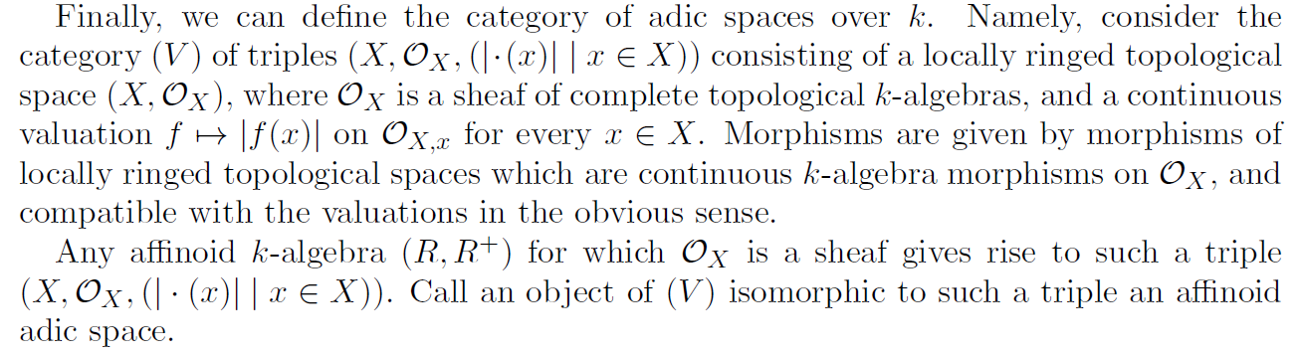

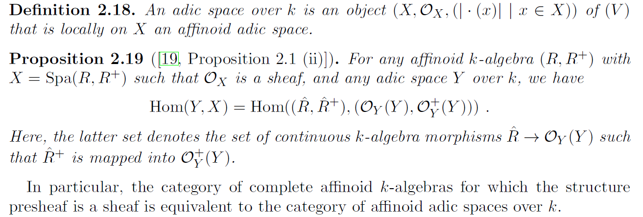

One of the simplest examples of an affinoid adic space is the affinoid adic space \Spa(\Q_p,\Z_p) over \Q_p. I’d like to say more about what the points and open subsets of this space look like. This space captures mixed characteristic (0,p).

We obtain perfectoid spaces as a full subcategory by gluing up affinoid perfectoid spaces, which are affinoid adic spaces given by perfectoid algebras. It is not hard to check that tilting glues.